**System Requirement Specification Document (SRS)**

For

**Qaraad Web Application**



|  |
| --- |
| Prepared by: ARK Techno Solutions  **Ph:** |(051) 5701044 **Cell:** (+92) 331-4409752  Email: contact@arksols.com, Website: www.arksols.com |

Table of Contents

1 Intended Audience 5

2 Purpose of This Document 5

3 The Purpose of the Project 5

3.1 Goals of the Project 5

3.2 Scope of the Project 6

Stakeholders 6

4 Users of the Product 6

4.1 The Users of the Product 6

5 Naming conventions and definitions 9

6 Relevant Facts and Assumptions 10

6.1 External Factors 10

6.2 Assumptions 10

7 Functional Requirements 11

Ease of use 61

Ease of learning 61

Security Requirements 61

7.2 Response Time 62

7.3 Startup Time 62

7.4 Shutdown Time 62

7.5 Number of Terminals 62

7.6 Number of Simultaneous Users 62

7.7 Expected Technological Requirements 62

7.8 Application Partner 62

7.9 Legal Requirements 62

7.10 Open Issues 62

7.11 Off the shelf solutions 63

7.12 Cutover 63

7.13 Risks 63

7.14 User Documentation and Training 63

Document Revision History

|  |  |  |  |
| --- | --- | --- | --- |
| **Created/Modified By** | **Date** | **Version Number** | **Reason for changes** |
| **ARK Techno Solutions** | October 10, 2018 | 1.0 | N/A |

# Intended Audience

Followings are the intended audience who could benefit and consult this SRS document:

* Qaraad’s Project Manager, Team Lead and Analyst
* Qaraad’s Test Engineers

# Purpose of This Document

This System Requirement Specification Document (SRS) is the output report of the Analysis Phase completed by the SD. This document is developed in a way that it precisely and accurately details the software product specifications in terms of its:

* Scope,
* Requirements,
* Objectives.

This SRS Document also covers various aspects of the project, including its non-functional requirements.

# The Purpose of the Project

Currently client I looking for the development of a web application that allow people to view ,buy and sell the products of type sales and auction of high value such as antiques, vintage and collectibles etc.

A need for this project under discussion has arisen due to many factors as mentioned below but not limited to:

A need to develop a web based application

To facilitate people to buy and sell valuable products

## Goals of the Project

Qaraad is an online application to buy and sell the different kind of products including vintage clothes, original posters, collectibles, rare books and anything else a user can find.  Application will allow the users to sell and buy different kind of products online. User type “Seller” will be able to add products with its specifications. User type “Buyer” will be able to buy the sales product. He will be able to get the auction product by placing the maximum bid. Administrator of the application will have privilege to respond to user requests, generating coupon code and viewing the auction and sales product.

## Scope of the Project

Scope of the project includes,

• Completely web based and 100% compatible with all browsers

* Simple and clean design, easy navigation for all type of users
* Application will allow users to avail services as per their access levels.
* There are three type of users
* Administrator
* Seller
* Buyer

Stakeholders

Developers, Test engineers, Project manager and clients are the stakeholders of this document.

# Users of the Product

## The Users of the Product

There are three different kinds of users.

1. Administrator
2. Seller
3. Buyer

**Administrator**: The Administrator user type is a user who is responsible for the administration of the entire system. Therefore, full access is granted in all areas by default. He will have following sections

* Dashboard
* User Requests
* All Requests
* Approved Requests
* Disapproved Requests
* All Users
  + All Buyers
  + All Sellers
* Coupon Code
  + Add Coupon Code
* Products
  + Auction Products
  + Sale Products
* Orders
* Social Media Links
* Logout

**Seller:** Following sections are designed for the user type “Seller” of the web application

* Dashboard
  + Owner First Name
  + Owner Last Name
  + Store Name
  + Business Phone Number
  + Business Email Address
  + Business Address
  + Business Registration Number
* Add Products
  + Product Name
  + Product Image (Maximum 4 in number)
  + Product Category
  + Product Price
  + Product Description
  + Sale Type ( Sale or Auction)
  + Quantity
  + Discount

* View Products
  + View Product
  + Edit Product
  + Delete Product
* Address
  + Add Address
    - First Name
    - Last Name
    - Country
    - State
    - City
    - Zip code/ Postal Code
    - Street Address line 1
    - Street Address line2
  + Address List
    - Full Name
    - Country
    - Postal/Zip Code
    - State
    - Actions
      * View ,Update ,Delete
* Orders list view
  + Order ID
  + Product Name
  + Order Date
  + Payment Status
  + Total Price
* Bids
  + Product Name
  + Auction Start Price
  + Auction Status
  + Max Bid

**Buyer:** Following sections are designed for the user type “Buyer” of the web application

* Dashboard
  + Display First and last name of user
  + Display contact number
* Profile
  + Change Account Password
    - Current Password
    - New Password
    - Confirm New Password
  + Contact Details
    - Telephone/Mobile Number
* Address
  + Add Address
    - First Name
    - Last Name
    - Country
    - State
    - City
    - Zip code/ Postal Code
    - Street Address line 1
    - Street Address line2
* Address List
  + Full Name
  + Country
  + Postal/Zip Code
  + State
  + Actions
    - View ,Update ,Delete
* All Orders list view
  + Order ID
  + Date
  + Total Price
  + Payment Status
  + Actions
    - View
* My Auctions
  + Product Name
  + Category
  + My Bid
  + Status
  + Bid Date and Time

# Naming conventions and definitions

|  |  |
| --- | --- |
| **Acronym** | **Definition** |
| Auction | A public sale in which goods or property are sold to the highest bidder. |
| Bid | An offer of a price, especially at an auction. |

# 

# Relevant Facts and Assumptions

## External Factors

Not applicable

## Assumptions

Users will be able to view all the Sales and Auction products. User has to sign up and get registered in order to purchase a sale product or to place a bid on auction product.

# Functional Requirements

## Admin Panel

**7.1.1 Sign In**

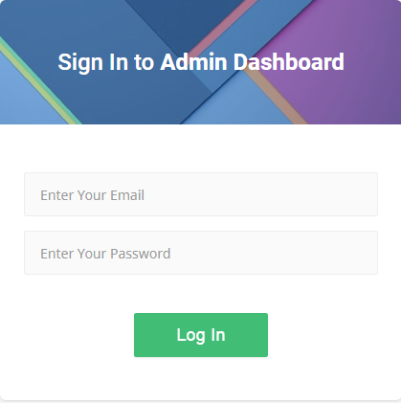

**Figure 7.1.1.1**

|  |  |  |  |  |
| --- | --- | --- | --- | --- |
| **Requirement Type**: | | | Functional Requirement | |
| **Description:** | | Admin will be able to sign in to the application. Sign in page will have the following functionality:   * Email ( Admin will be able to enter his email address in this input field) * Password ( Admin will be able to enter his password in this input field) * Login Button ( admin will be logged in to the system on clicking this button) | | |
| **Rationale:** | | It will help the admin to log in to the application | | |
| **Fit Criteria:** | | Only admin will be able to login to the admin panel | | |
| **Source:** | |  | | |
| **Supporting Material (if any):** | | | | Client Meetings |
| **History:** |  | | | |

**7.1.2 Header**



**Figure 7.1.2.1**

|  |  |  |  |  |
| --- | --- | --- | --- | --- |
| **Requirement Type**: | | | Functional Requirement | |
| **Description:** | | The header contain the following options:   1. Application name 2. Menu bar  * It will hide and show the left menu panel  1. Screen resolution icon  * It will maximize and restore the screen  1. Profile icon  * Profile * Settings * Logout | | |
| **Rationale:** | | Ease of access to the admin | | |
| **Fit Criteria:** | | Only admin will be able to access the header | | |
| **Source:** | |  | | |
| **Supporting Material (if any):** | | | | Client Meetings |
| **History:** |  | | | |

**7.1.3 Profile Icon**

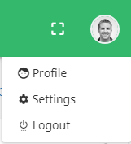

**Figure 7.1.3.1**



**Figure 7.1.3.2**

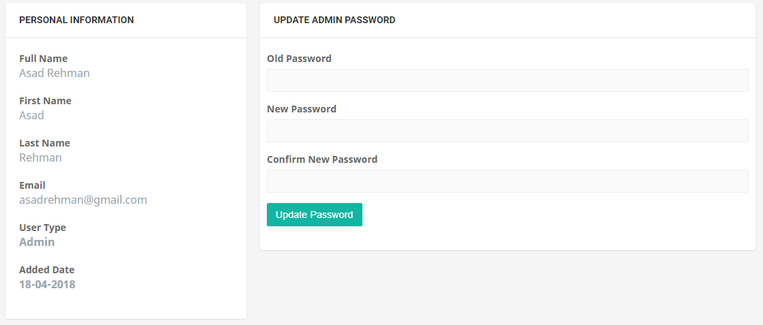

**Figure 7.1.3.3**

|  |  |  |  |  |
| --- | --- | --- | --- | --- |
| **Requirement Type**: | | | Functional Requirement | |
| **Description:** | | When user click the profile icon ,following options will be displayed   1. Profile 2. Logout 3. Profile section will contain the:  * Header ( User profile and name will be displayed here) * Personal Information (not editable) * Full Name * First Name * Last Name * Email * User type * Added Date * Update Password * Old Password * New Password * Confirm New Password * “Update Password” button for updating the password | | |
| **Rationale:** | | Admin can view his information and can update the password | | |
| **Fit Criteria:** | | Only Authorized admin can access the profile section | | |
| **Source:** | |  | | |
| **Supporting Material (if any):** | | | | Client Meetings |
| **History:** |  | | | |

**7.1.4 Left Panel**

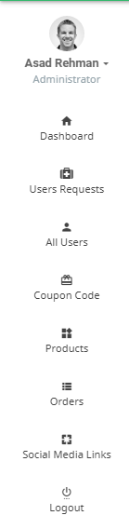

**Figure 7.1.4.1**

|  |  |  |  |  |
| --- | --- | --- | --- | --- |
| **Requirement Type**: | | | Functional Requirement | |
| **Description:** | | The left panel contains the following options:   1. Admin Profile Drop down 2. Dashboard 3. Users Requests 4. All users 5. Coupon Code 6. Products 7. Orders 8. Social Media Links 9. Logout | | |
| **Rationale:** | | Ease of Access. As all the admin functionality can be accessed from left panel | | |
| **Fit Criteria:** | | Only Authorized admin can access the left panel | | |
| **Source:** | |  | | |
| **Supporting Material (if any):** | | | | Client Meetings |
| **History:** |  | | | |

**7.1.4.1 Dashboard**

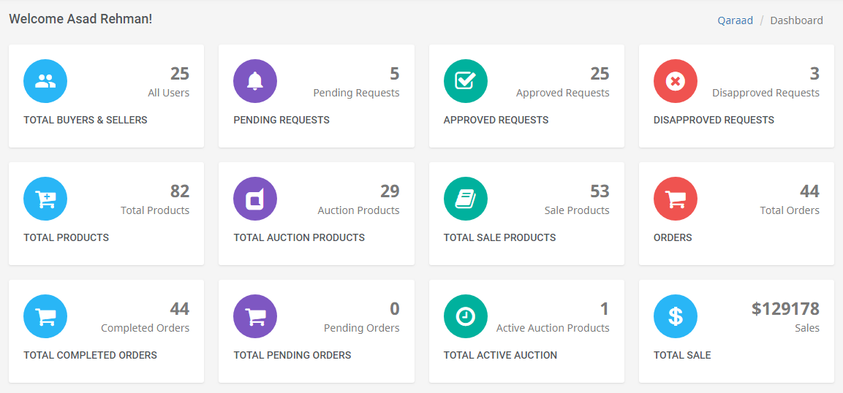

**Figure 7.1.4.1.1**

|  |  |  |  |  |
| --- | --- | --- | --- | --- |
| **Requirement Type**: | | | Functional Requirement | |
| **Description:** | | Dashboard will give statistics information about the following:   1. Total number of Buyers and Sellers 2. Total number of pending requests 3. Total number of approved requests 4. Total number of disapproved requests 5. Total number of products 6. Total number of auction products 7. Total number of sale products 8. Total number of auction products 9. Total number of orders 10. Total number of completed orders 11. Total number of pending orders 12. Total number of active auction 13. Total sales 14. Information will be in the form of tiles (see figure 7.1.4.1.1 for more information) | | |
| **Rationale:** | | Help admin to view the statistics | | |
| **Fit Criteria:** | | Only Authorized admin can view the statistics | | |
| **Source:** | |  | | |
| **Supporting Material (if any):** | | | | Client Meetings |
| **History:** |  | | | |

**7.1.4.2 Users Requests**

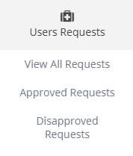

**Figure 7.1.4.2.1**

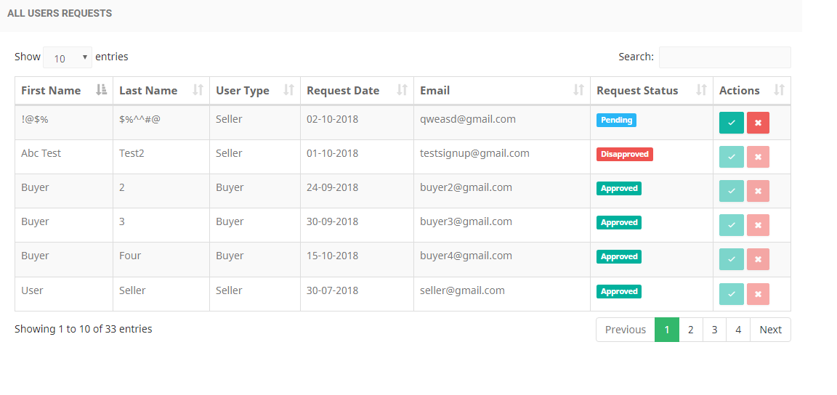

**Figure 7.1.4.2.2**

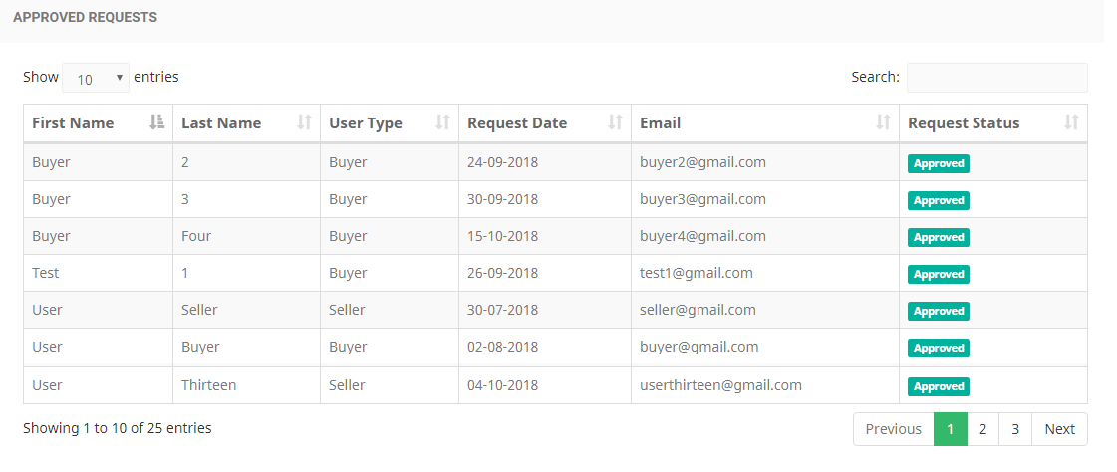

**Figure 7.1.4.2.3**

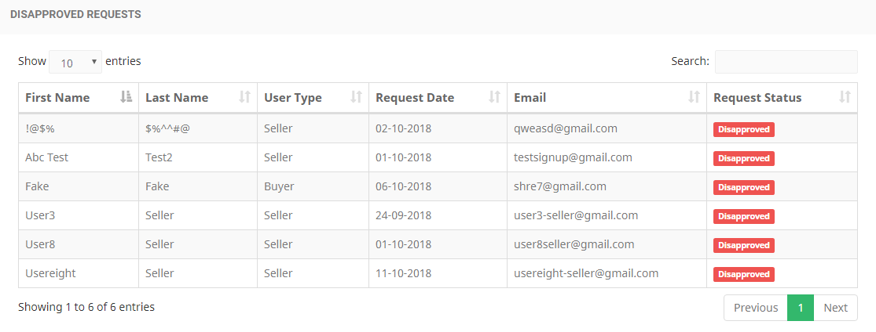

**Figure 7.1.4.2.4**

|  |  |  |  |  |
| --- | --- | --- | --- | --- |
| **Requirement Type**: | | | Functional Requirement | |
| **Description:** | | 1. When user click the Users Requests ,following options will be displayed:  * View All requests * Approved Requests * Disapproved Requests  1. The View All requests option will contain the following information:  * First Name * Last Name * User Type * Request Date * Email * Request Status (it can be approved ,disapproved or pending) * Actions ( Admin can Accept or reject the request)   See figure 7.1.4.2.2 for more information   1. The Approved requests option will contain the following information:  * First Name * Last Name * User type * Request Date * Email * Request Status ( Approved)   See figure 7.1.4.2.3 for more information   1. The Disapproved requests option will contain the following information:  * First Name * Last Name * User type * Request Date * Email * Request Status ( Disapproved) | | |
| **Rationale:** | | Help the admin to handle and view User Requests section | | |
| **Fit Criteria:** | | Only Authorized admin can access User Requests section | | |
| **Source:** | |  | | |
| **Supporting Material (if any):** | | | | Client Meetings |
| **History:** |  | | | |

**7.1.4.3 All Users**

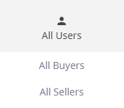

**Figure 7.1.4.3.1**

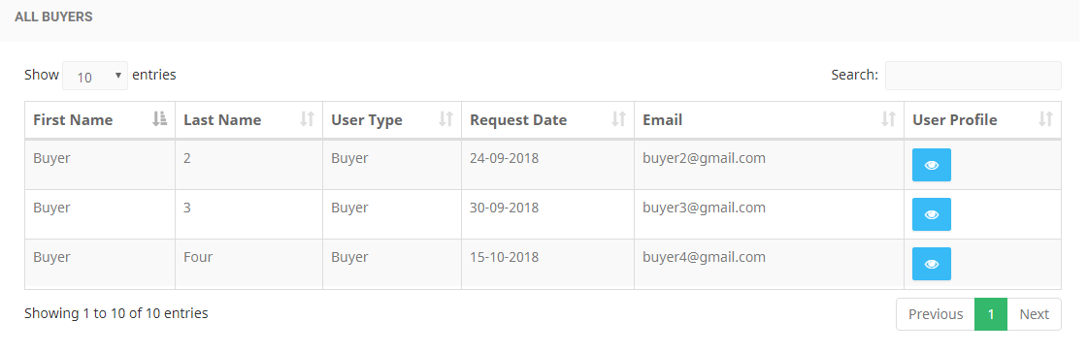

**Figure 7.1.4.3.2**

## 

**Figure 7.1.4.3.3**

## 5.png

**Figure 7.1.4.3.4**

|  |  |  |  |  |
| --- | --- | --- | --- | --- |
| **Requirement Type**: | | | Functional Requirement | |
| **Description:** | | 1. The “All Users” will contain the following option:  * All Buyers * All Sellers  1. The “All Buyers” option will contain the following information:  * First Name * Last Name * User type * Request Date * Email * User Profile ( see figure 7.1.4.3.3 for more information)   See figure 7.1.4.3.2 for more information   1. The “All Sellers” option will contain the following information:  * First Name * Last Name * User type * Request Date * Email * Seller Profile   See figure 7.1.4.3.4 for more information | | |
| **Rationale:** | | Help admin to view the Users of the application | | |
| **Fit Criteria:** | | Only Authorized admin can view the “All Users” section | | |
| **Source:** | |  | | |
| **Supporting Material (if any):** | | | | Client Meetings |
| **History:** |  | | | |

**7.1.4.4 Coupon Code**

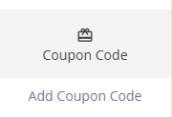

**Figure 7.1.4.4.1**

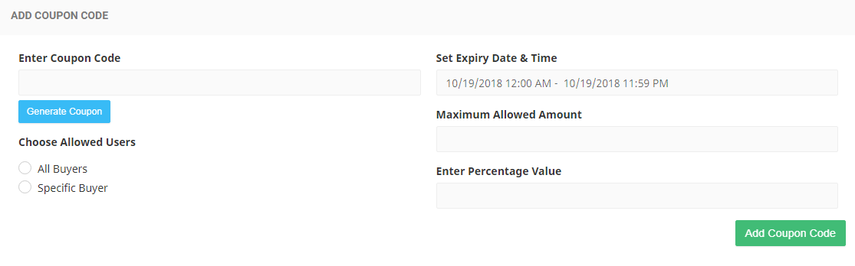

**Figure 7.1.4.4.2**

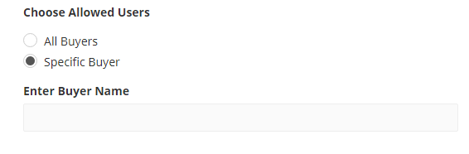

**Figure 7.1.4.4.3**

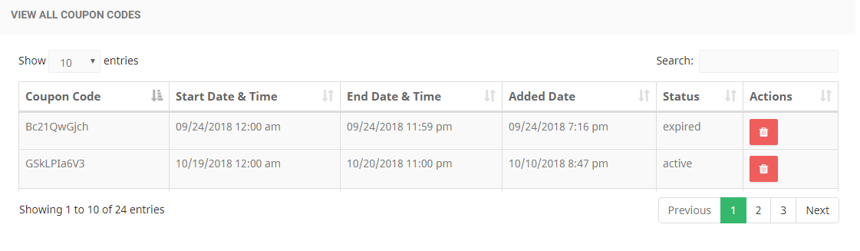

**Figure 7.1.4.4.4**

|  |  |  |  |  |
| --- | --- | --- | --- | --- |
| **Requirement Type**: | | | Functional Requirement | |
| **Description:** | | 1. The Coupon code will contain the following option:  * Add Coupon Code  1. The Add coupon code will contain the following input fields:  * Enter Coupon Code (admin can enter code to generate self written coupon code) * “Generate Coupon” button ( it will generate code automatically) * Allowed Users * All buyers * Specific Buyer (for specific buyer, buyer name will have to be entered. See figure 7.1.4.4.3) * Expiry Date and Time * Maximum allowed amount * Percentage value * “Add coupon code” button for generating the coupon code  1. The generated coupon code can be viewed. Each generated code will contain the following information  * Coupon Code * Start Date & Time * End Date & Time * Added Date * Status * Actions * Delete   See figure 7.1.4.4.4 for more information | | |
| **Rationale:** | | Admin can generate coupon code for providing discount to the buyers | | |
| **Fit Criteria:** | | Only Authorized admin can generate and view coupon code | | |
| **Source:** | |  | | |
| **Supporting Material (if any):** | | | | Client Meetings |
| **History:** |  | | | |

## 7.1.4.5 Products

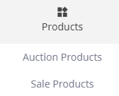

**Figure 7.1.4.5.1**

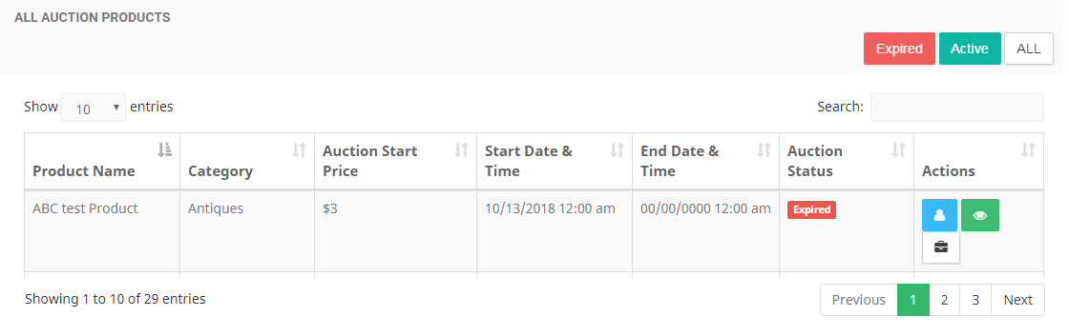

**Figure 7.1.4.5.2**

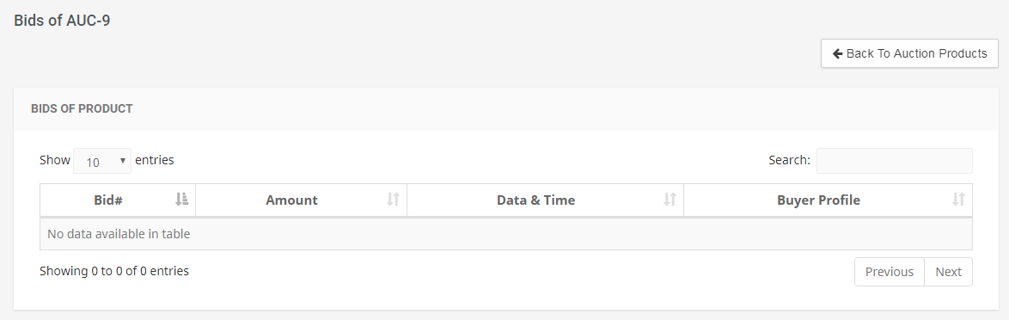

**Figure 7.1.4.5.2a**

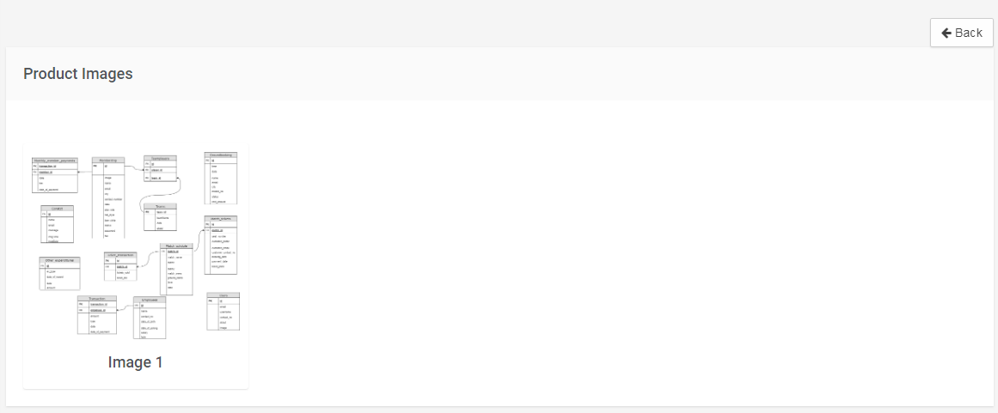

**Figure 7.1.4.5.2b**

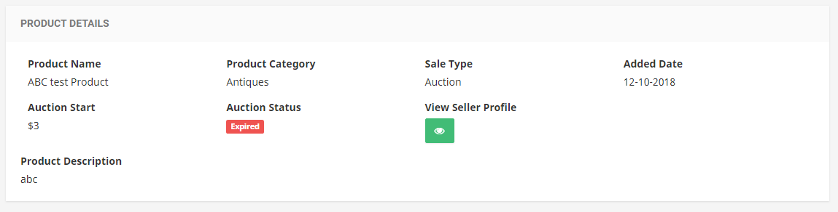

**Figure 7.1.4.5.2c**

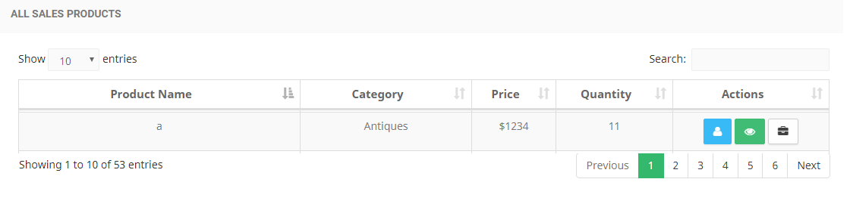

**Figure 7.1.4.5.3**

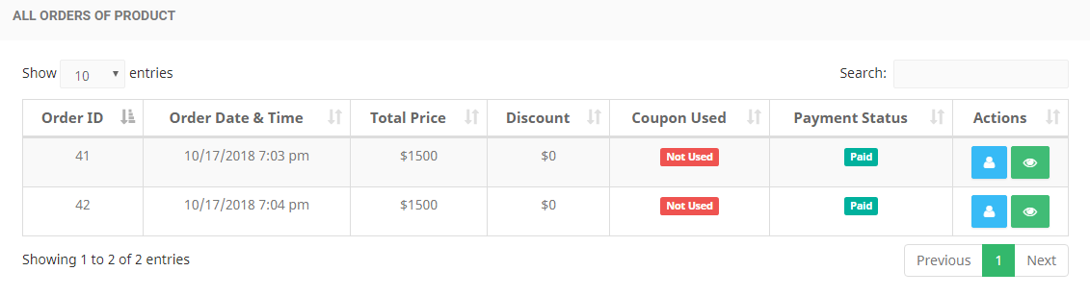

**Figure 7.1.4.5.3a**

|  |  |  |  |  |
| --- | --- | --- | --- | --- |
| **Requirement Type**: | | | Functional Requirement | |
| **Description:** | | 1. “Products” will contain the following options:  * Auction Products * Sale Products  1. The auction products will contain:  * Expired , Active and All Search Filters for filtering out the specific auction status products * Product Name * Category * Auction Start Price * Start Date and Time * End Date and Time * Auction Status * Actions * View Seller Profile  1. Seller Profile will be shown  * View Product Bids (figure 7.1.4.5.2a for more information)  1. Bid number 2. Amount 3. Date and Time 4. Buyer Profile view 5. Back button to go back to auction products  * View Product Details  1. Back Button (take back to auction products) (figure 7.1.4.5.2b) 2. Product Images (figure 7.1.4.5.2b) 3. Product Name (figure 7.1.4.5.2c) 4. Product Category (figure 7.1.4.5.2c) 5. Sale Type (figure 7.1.4.5.2c) 6. Added Date (figure 7.1.4.5.2c) 7. Auction Start (figure 7.1.4.5.2c) 8. Auction Status (figure 7.1.4.5.2c) 9. View Seller Profile button (figure 7.1.4.5.2c) 10. Product Description (figure 7.1.4.5.2c) 11. The sale products will contain the following information:  * Product Name * Category * Price * Quantity * Actions * View Seller Profile (same as that of auction products) * View Product orders (Figure 7.1.4.5.3a)  1. Order Id 2. Order Date & Time 3. Total Price 4. Discount 5. Coupon used 6. Payment Status 7. Actions 8. Buyer profile 9. View order Details and Invoice  * View Product Details (same as that of auction products) | | |
| **Rationale:** | | Admin can handle the auction and sale products | | |
| **Fit Criteria:** | | Only Authorized admin can access Products section | | |
| **Source:** | |  | | |
| **Supporting Material (if any):** | | | | Client Meetings |
| **History:** |  | | | |

## Orders

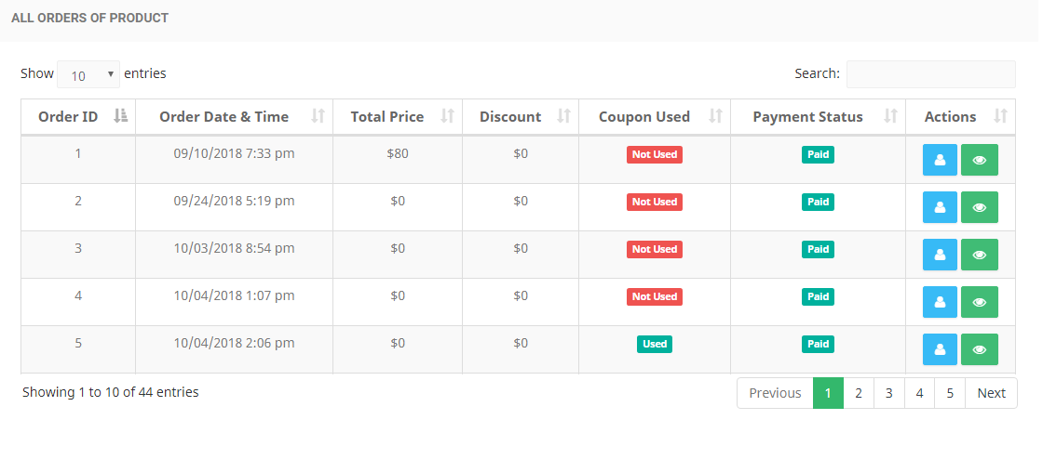

**Figure 7.1.4.6.1**

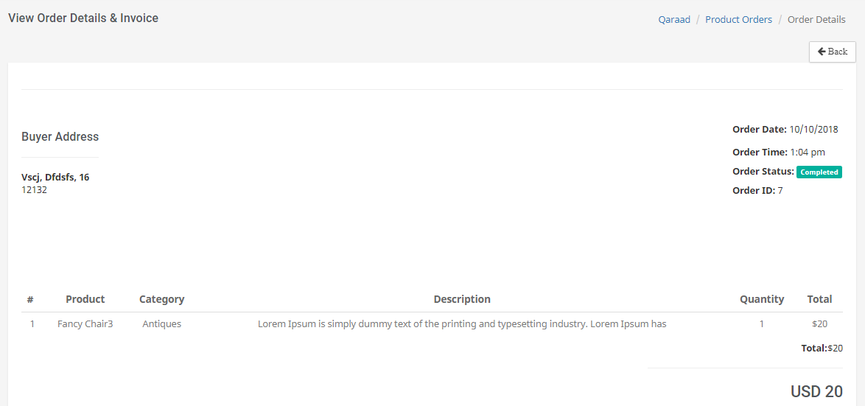

**Figure 7.1.4.6.2**

|  |  |  |  |  |
| --- | --- | --- | --- | --- |
| **Requirement Type**: | | | Functional Requirement | |
| **Description:** | | 1. The “Orders” will contain the following information:  * Order ID * Order Date & Time * Total Price * Discount * Coupon used * Payment Status * Actions * Buyer profile * View order Details and Invoice  1. Back Button (it will take the user back to all orders) 2. Buyer Address 3. Order Date 4. Order Time 5. Order Status 6. Order ID 7. Product ID 8. Product Name 9. Product Category 10. Product Description 11. Quantity 12. Total (single order) 13. Total (all orders) 14. Price in USD | | |
| **Rationale:** | | Admin can view the orders details to contact the buyer | | |
| **Fit Criteria:** | | Only Authorized admin can access orders section | | |
| **Source:** | |  | | |
| **Supporting Material (if any):** | | | | Client Meetings |
| **History:** |  | | | |

## Social Media Links

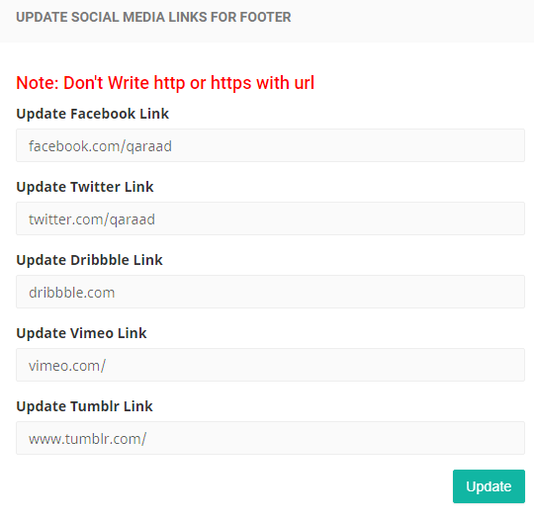

**Figure 7.1.4.7.1**



**Figure 7.1.4.7.2**

|  |  |  |  |  |
| --- | --- | --- | --- | --- |
| **Requirement Type**: | | | Functional Requirement | |
| **Description:** | | 1. In Social Media links section , social media links can be updated (figure 7.1.4.7.1) 2. Url will be written without http or https 3. These updates will be reflected to the footer (figure 7.1.4.7.2) 4. Update button | | |
| **Rationale:** | | The application can be followed by different social media links | | |
| **Fit Criteria:** | | Only authorized admin can update the social media links | | |
| **Source:** | |  | | |
| **Supporting Material (if any):** | | | | Client Meetings |
| **History:** |  | | | |

* + - 1. **Logout**

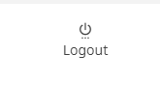

**Figure 7.1.4.8.1**

|  |  |  |  |  |
| --- | --- | --- | --- | --- |
| **Requirement Type**: | | | Functional Requirement | |
| **Description:** | | 1. The logout option will logout the application 2. Control will be shifted to login page of admin | | |
| **Rationale:** | | The admin can logout from the application | | |
| **Fit Criteria:** | | Only authorized admin can access the logout functionality | | |
| **Source:** | |  | | |
| **Supporting Material (if any):** | | | | Client Meetings |
| **History:** |  | | | |

## Registration and Sign in Page

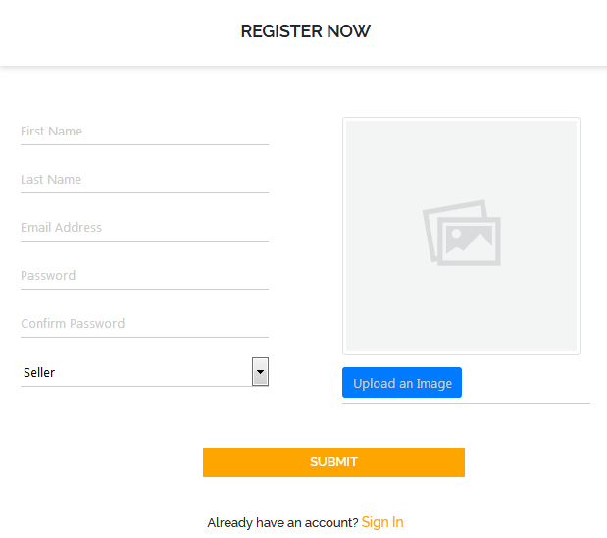

**Figure 7.2.1**

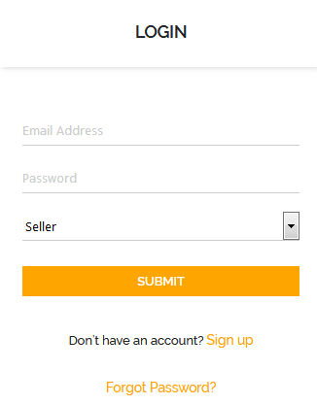

**Figure 7.2.2**

|  |  |  |  |  |
| --- | --- | --- | --- | --- |
| **Requirement Type**: | | | Functional Requirement | |
| **Description:** | | Buyer and Seller both have to sign up first to avail the services of the application. Sign up page has the following fields:   1. First Name 2. Last Name 3. Email Address 4. Password 5. Confirm Password 6. A drop down ,where user can select the account type (i.e. seller or buyer) 7. User can set his profile picture through “Upload an image” button 8. A submit button , which will submit the user request to the admin   For more detail check Figure 7.2.1.  The login page has the following   1. Email Address input field 2. Password input field 3. A drop down of two options; buyer and seller   For more detail check Figure 7.2.1. | | |
| **Rationale:** | | It will help the users to get registered to the web application | | |
| **Fit Criteria:** | | Buyer and seller will sign up to the application | | |
| **Source:** | |  | | |
| **Supporting Material (if any):** | | | | Client Meetings |
| **History:** |  | | | |

## 7.2 Login Page



**Figure 7.2.1**

|  |  |  |  |  |
| --- | --- | --- | --- | --- |
| **Requirement Type**: | | | Functional Requirement | |
| **Description:** | | The login page has the following   1. Email Address input field 2. Password input field 3. A drop down of two options; buyer and seller   For more detail check Figure 7.2.1. | | |
| **Rationale:** | | This will help the user to avail the services of the web application | | |
| **Fit Criteria:** | | Authorized users ,admin and requested users can login to the application | | |
| **Source:** | |  | | |
| **Supporting Material (if any):** | | | | Client Meetings |
| **History:** |  | | | |

## 7.3 Seller Panel



**Figure 7.3**

The above figure shows the options that the user type “Seller” has. These options are described in detail in the following sections.

**7.3.1 Dashboard**

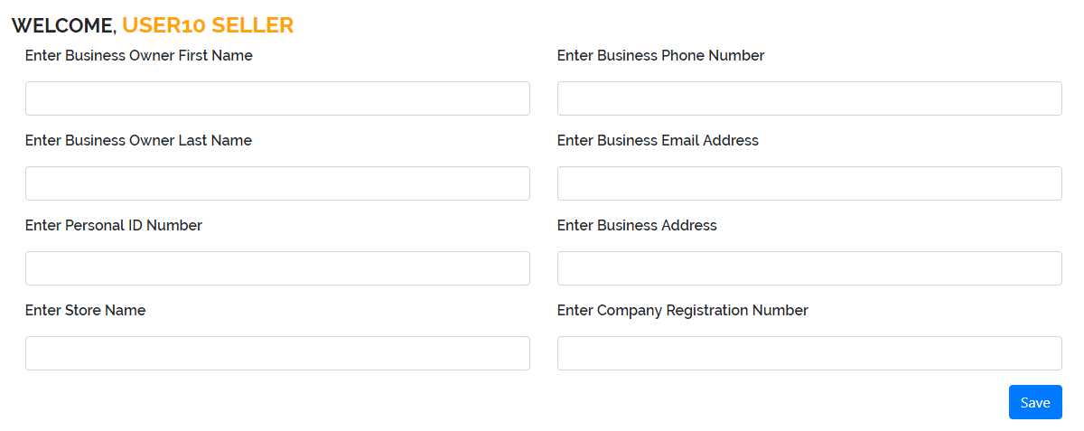

**Figure 7.3.1.1**

|  |  |  |  |  |
| --- | --- | --- | --- | --- |
| **Requirement Type**: | | | Functional Requirement | |
| **Description:** | | The Dashboard takes the following information from the user.   1. Business Owner First Name 2. Business Owner Last Name 3. Personal ID Number 4. Store Name 5. Business Phone Number 6. Business Email Address 7. Business Address 8. Company Registration Number 9. A save button which will save the user information on his dashboard | | |
| **Rationale:** | | This will help to view his business details | | |
| **Fit Criteria:** | | Authorized users will be able to set his profile by entering business details | | |
| **Source:** | |  | | |
| **Supporting Material (if any):** | | | | Client Meetings |
| **History:** |  | | | |

**7.3.2 Add Products**

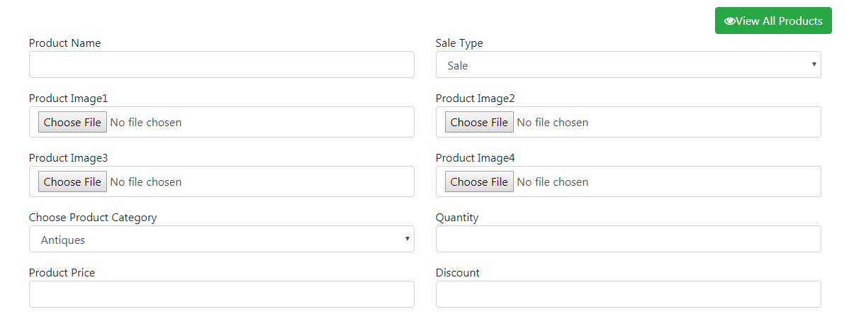

**Figure 7.3.2.1**

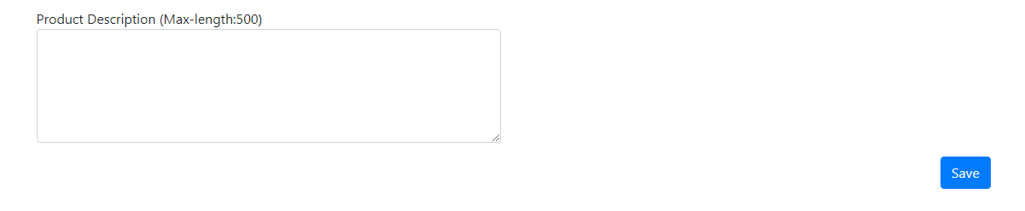

**Figure 7.3.2.2**

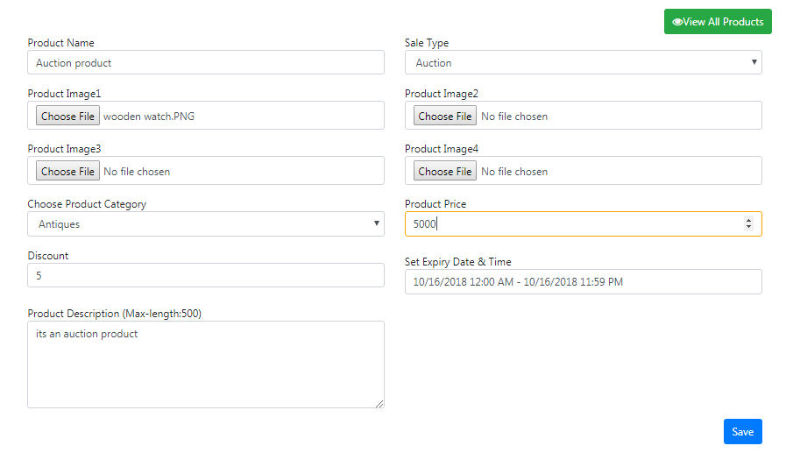

**Figure 7.3.2.3**

|  |  |  |  |  |  |
| --- | --- | --- | --- | --- | --- |
| **Requirement Type**: | | | Functional Requirement | | |
| **Description:** | | The Seller of the application can add the product for selling purpose by adding following details:   1. Product Name 2. Product Image( maximum four but at least one is mandatory) 3. Product Category 4. Product Price 5. Sale type (it is a drop down for selling the sale type of item i.e. Auction or Sale). By default sale user type is selected. 6. Quantity (must be less than or equal to 5000) 7. Discount (must be less than or equal to 5000) 8. Description (maximum 500 words about the selling product)-> text editor 9. Save button for saving the details about the product 10. Auction Product (Figure 7.3.2.3)  * Expiry Date & Time is an extra input field that user has to set for the auction product | | |
| **Rationale:** | | User will be able to add a product to sell | | |
| **Fit Criteria:** | | User type “Seller” will be able to add product | | |
| **Source:** | |  | | |
| **Supporting Material (if any):** | | | | Client Meetings |
| **History:** |  | | | |

## 7.3.3 View Products

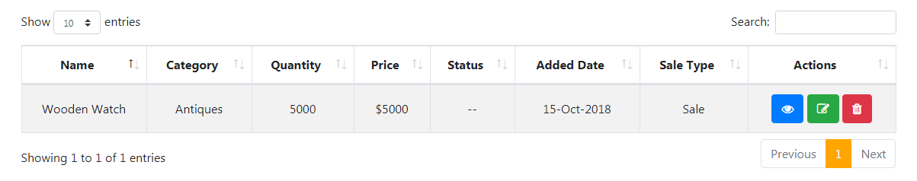

**Figure 7.3.3.1**

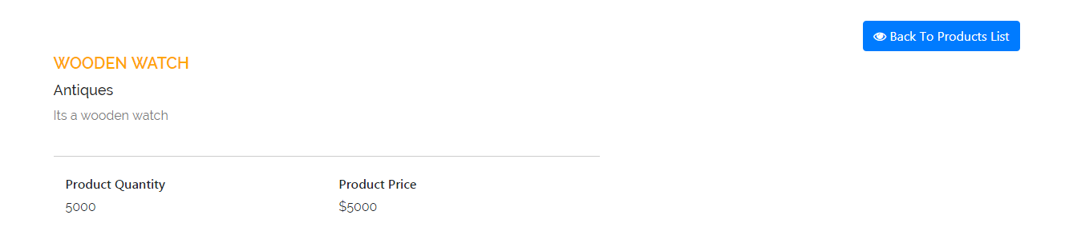

**Figure 7.3.3.2**

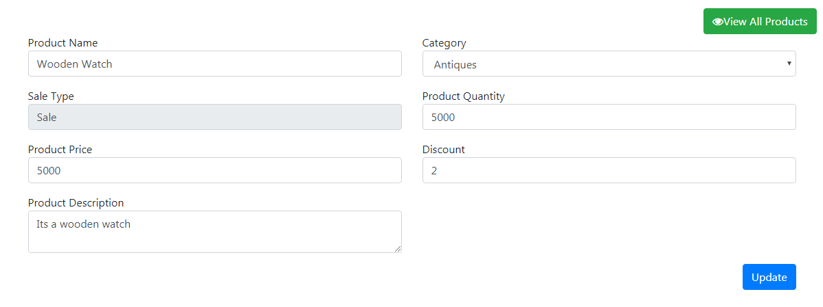

**Figure 7.3.3.3**

|  |  |  |  |  |
| --- | --- | --- | --- | --- |
| **Requirement Type**: | | | Functional Requirement | |
| **Description:** | | When user click the View Products Tab ,following information is displayed   1. User will be able to view the Name ,Category ,Quantity , Price , Status , Added Data , ,Sale Type of the product 2. User will be able to perform three actions (view ,update and delete)   For more details check Figure 7.3.3.1   1. View Product (Figure 7.3.3.2)  * Product name, Product type, Product description, Quantity and price will be viewed. * A back button which will shift he control to the product list  1. Update Product (Figure 7.3.3.3)  * Product Name, Category, Quantity, Price, Description, Sale Type and discount will be the fields that can be updated. * A button which will take user to the All product view  1. User will be able to delete the added product | | |
| **Rationale:** | | User will be able to view ,update and delete the added product | | |
| **Fit Criteria:** | | User type “Seller” will be able to access the View Product tab | | |
| **Source:** | |  | | |
| **Supporting Material (if any):** | | | | Client Meetings |
| **History:** |  | | | |

## 7.3.4 Add Address

## 

**Figure 7.3.4.1**

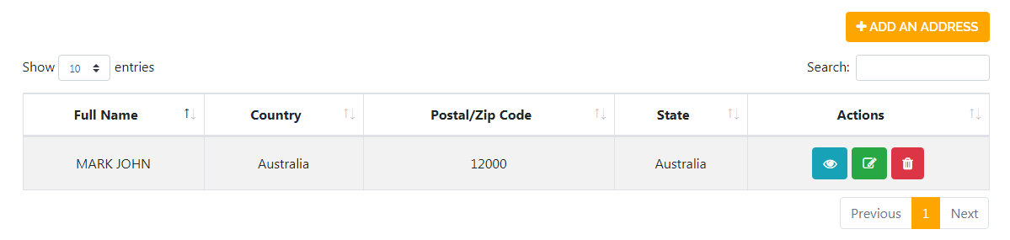

**Figure 7.3.4.2**

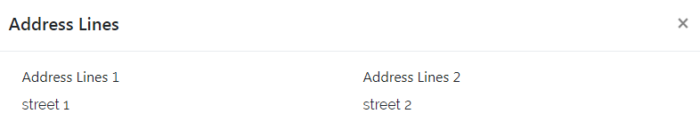

**Figure 7.3.4.3**

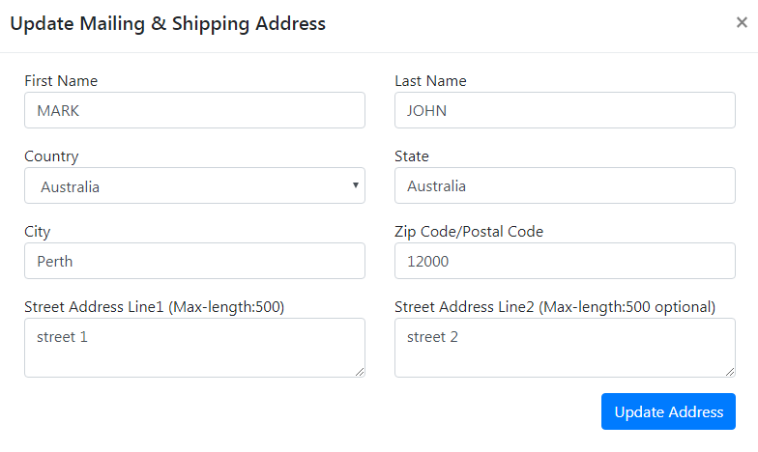

**Figure 7.3.4.4**

|  |  |  |  |  |
| --- | --- | --- | --- | --- |
| **Requirement Type**: | | | Functional Requirement | |
| **Description:** | | When user click the Address tab the address section is displayed. When user click the Add an address button ,the pop up is appeared having following input fields   1. First Name 2. Last Name 3. Country 4. State 5. City 6. Zip code/Postal code 7. Street Address line 1 8. Street Address line 2 9. A save button which will save the address 10. The added address will be saved in the form of table list. (Figure 7.3.4.2) 11. User is able to add multiple address by clicking the “Add an Address” button   See figure 7.3.4.2 to see more information   1. User will be able to perform three actions (view ,update ,delete) 2. When user click the view button , the address lines of the user will be displayed (Figure 7.3.4.3) 3. When user click the update button ,the pop up will appear with the auto filled user data (Figure 7.3.4.4)  * Update button which will save the updated address.  1. The delete button will delete the added address | | |
| **Rationale:** | | This will help the user to add his address | | |
| **Fit Criteria:** | | Buyer and seller both need to add his address | | |
| **Source:** | |  | | |
| **Supporting Material (if any):** | | | | Client Meetings |
| **History:** |  | | | |

## 7.3.5 Orders

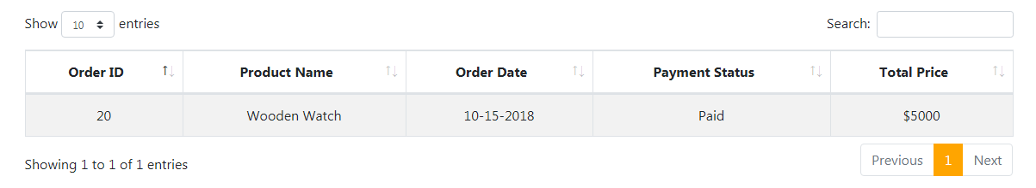

**Figure 7.3.5.1**

|  |  |  |  |  |
| --- | --- | --- | --- | --- |
| **Requirement Type**: | | | Functional Requirement | |
| **Description:** | | Orders tab display user orders specifically. When user click the Orders tab ,following information is displayed:   1. Order ID 2. Product Name 3. Order Date 4. Payment Status 5. Total Price   See Figure 7.3.5.1 to see more information | | |
| **Rationale:** | | This will help the user to view his order details | | |
| **Fit Criteria:** | | All seller types will have this order section | | |
| **Source:** | |  | | |
| **Supporting Material (if any):** | | | | Client Meetings |
| **History:** |  | | | |

## 7.3.6 Bids

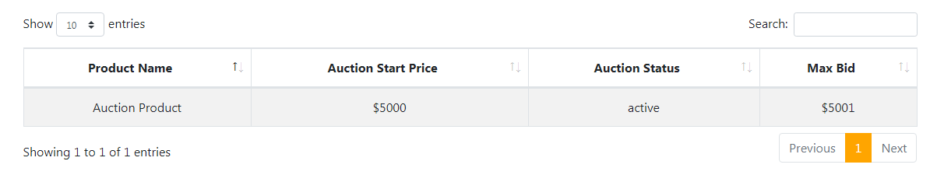

**Figure 7.3.6.1**

|  |  |  |  |  |
| --- | --- | --- | --- | --- |
| **Requirement Type**: | | | Functional Requirement | |
| **Description:** | | Bids tab display the maximum bid information of the auction product of the user. When user click the bids tab ,following information is displayed:   1. Product Name 2. Auction Start Price 3. Auction Status 4. Maximum Bid   See Figure 7.3.6.1 to see more information | | |
| **Rationale:** | | This will help the user to view the maximum bid information of the auction product | | |
| **Fit Criteria:** | | All seller types will have this bids section | | |
| **Source:** | |  | | |
| **Supporting Material (if any):** | | | | Client Meetings |
| **History:** |  | | | |

## 7.4 Buyer Panel



**Figure 7.4**

The above figure shows the options that user type “Buyer” has.

**7.4.1 Dashboard**



**Figure 7.4.1.1**

|  |  |  |  |  |
| --- | --- | --- | --- | --- |
| **Requirement Type**: | | | Functional Requirement | |
| **Description:** | | The Dashboard of the Buyer display the following information   1. User first and last Name followed by the Welcome text. 2. Phone number of the user. This information is empty ,when user first time logged in to the system. | | |
| **Rationale:** | | This will help the user to view his information | | |
| **Fit Criteria:** | | Authorized buyers | | |
| **Source:** | |  | | |
| **Supporting Material (if any):** | | | | Client Meetings |
| **History:** |  | | | |

**7.4.2 Profile**

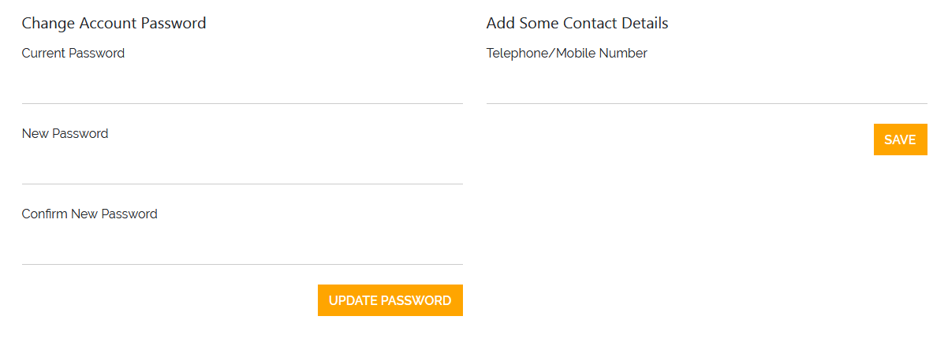

**Figure 7.4.2.1**

|  |  |  |  |  |
| --- | --- | --- | --- | --- |
| **Requirement Type**: | | | Functional Requirement | |
| **Description:** | | The profile section contain the following information   1. It allows the user to change his password by entering the following three fields  * Current Password * New Password * Confirm New Password  1. Update Password button will update the user password 2. It allow the user to enter his Contact details  * Telephone number or Mobile number | | |
| **Rationale:** | | This will help the user to enter his contact number or to change his password. | | |
| **Fit Criteria:** | | Authorized buyers | | |
| **Source:** | |  | | |
| **Supporting Material (if any):** | | | | Client Meetings |
| **History:** |  | | | |

7.4.3 Address

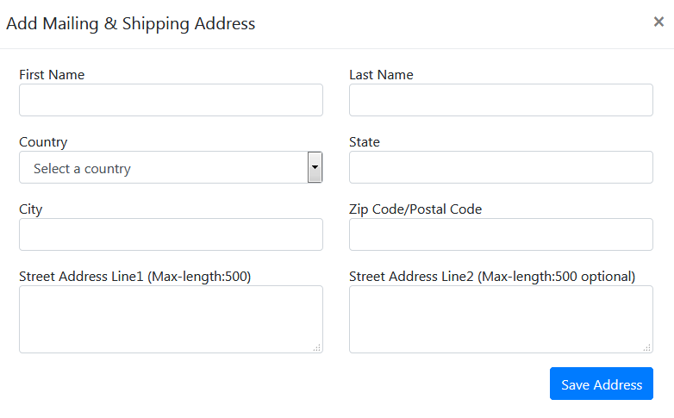

**Figure 7.4.3.1**

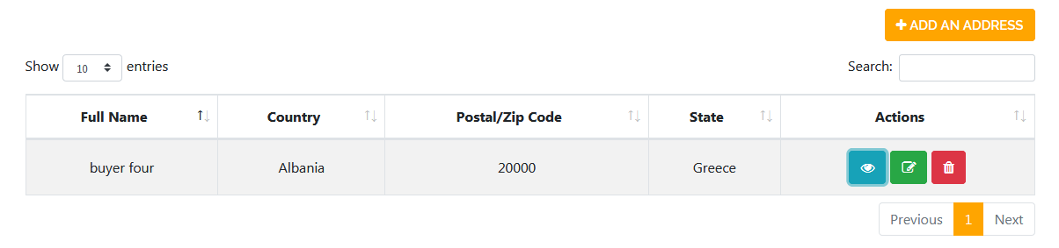

**Figure 7.4.3.2**

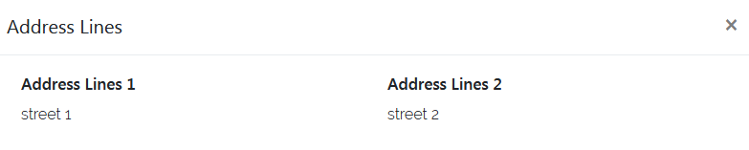

**Figure 7.4.3.3**

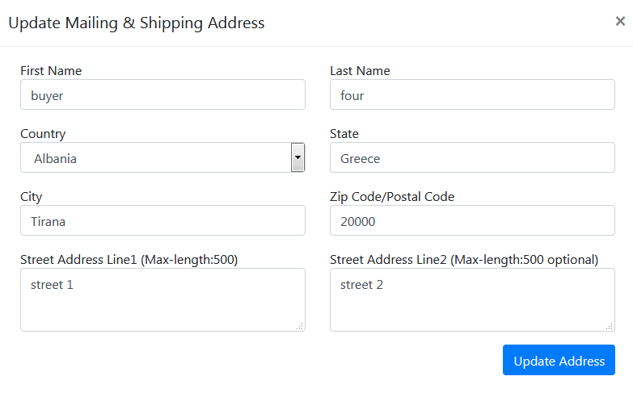

**Figure 7.4.3.4**

|  |  |  |  |  |
| --- | --- | --- | --- | --- |
| **Requirement Type**: | | | Functional Requirement | |
| **Description:** | | When user click the Address tab the address section is displayed. When user click the Add an address button ,the pop up is appeared having following input fields   1. First Name 2. Last Name 3. Country 4. State 5. City 6. Zip code/Postal code 7. Street Address line 1 8. Street Address line 2 9. A save button which will save the address 10. The added address will be saved in the form of table list. (Figure 7.4.3.2) 11. User is able to add multiple address by clicking the “Add an Address” button   See figure 7.4.3.2 to see more information   1. User will be able to perform three actions (view ,update ,delete) 2. When user click the view button , the address lines of the user will be displayed (Figure 7.4.3.3) 3. When user click the update button ,the pop up will appear with the auto filled user data (Figure 7.4.3.4)  * Update button which will save the updated address.  1. The delete button will delete the added address | | |
| **Rationale:** | | This will help the user to add his address | | |
| **Fit Criteria:** | | Buyer and seller both need to add his address | | |
| **Source:** | |  | | |
| **Supporting Material (if any):** | | | | Client Meetings |
| **History:** |  | | | |

**7.4.4 All Orders**

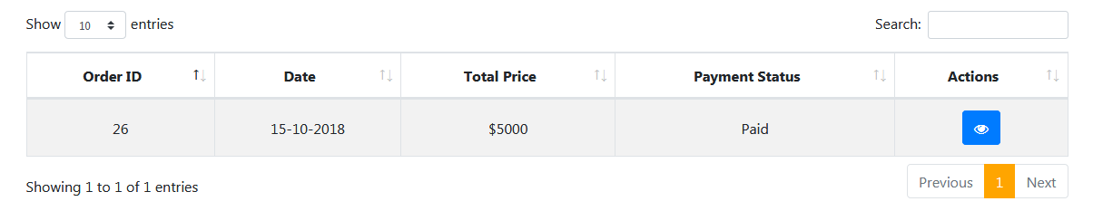

**Figure 7.4.4.1**

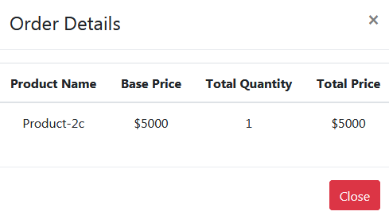

**Figure 7.4.4.2**

|  |  |  |  |  |
| --- | --- | --- | --- | --- |
| **Requirement Type**: | | | Functional Requirement | |
| **Description:** | | The “All Orders” section contains the information about the order that the buyer placed. It shows the following information about the booked order.   1. Order ID 2. Date 3. Total Price 4. Payment Status 5. Action. User is able to view the order details as well. See Figure 7.4.4.2 for more information.   See figure 7.4.4.1 for more information. | | |
| **Rationale:** | | This will help the user to see his ordered products in detail. | | |
| **Fit Criteria:** | | Authorized buyers | | |
| **Source:** | |  | | |
| **Supporting Material (if any):** | | | | Client Meetings |
| **History:** |  | | | |

**7.4.5 My Auctions**

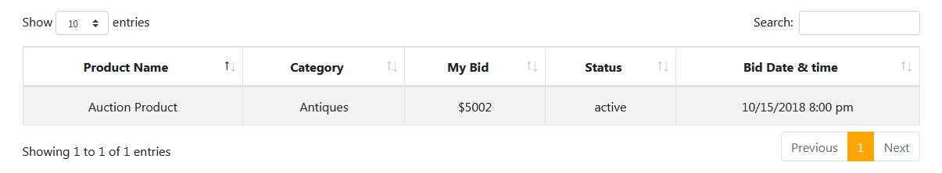

**Figure 7.4.5.1**

|  |  |  |  |  |
| --- | --- | --- | --- | --- |
| **Requirement Type**: | | | Functional Requirement | |
| **Description:** | | The “My Auctions” section contains the information about the product on which buyer has placed the bid. His maximum bid on the product will be shown with the following information.   1. Product Name 2. Category 3. My Bid 4. Status 5. Bid Date & Date   See figure 7.4.5.1 for more information. | | |
| **Rationale:** | | This will help the user to see his bid information on the auction product in detail. | | |
| **Fit Criteria:** | | Authorized buyers | | |
| **Source:** | |  | | |
| **Supporting Material (if any):** | | | | Client Meetings |
| **History:** |  | | | |

**7.4.6 Sale Product Buying Process**

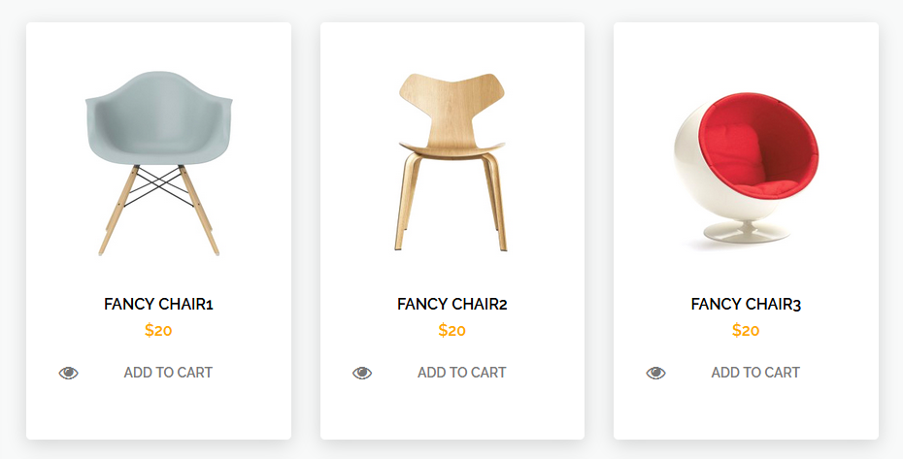

**Figure 7.4.6.1**



**Figure 7.4.6.2**



**Figure 7.4.6.3**

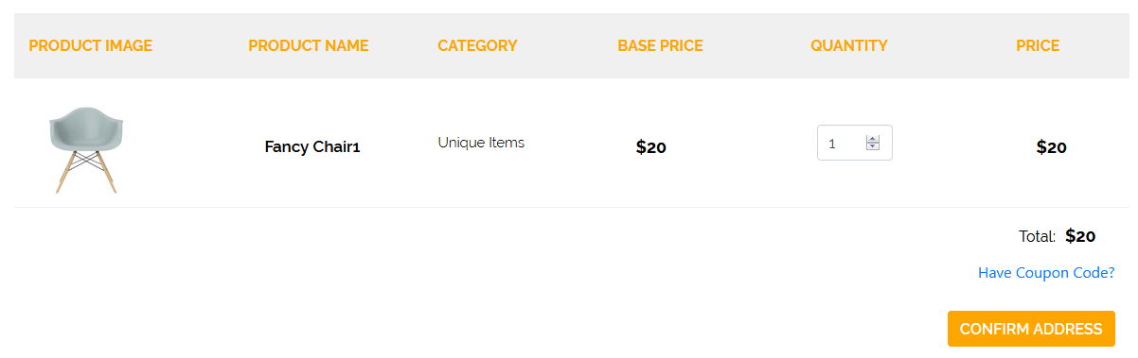

**Figure 7.4.6.4**

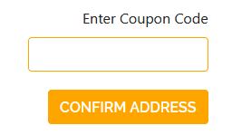

**Figure 7.4.6.5**

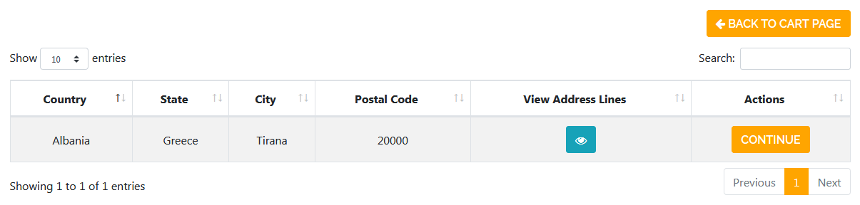

**Figure 7.4.6.6**

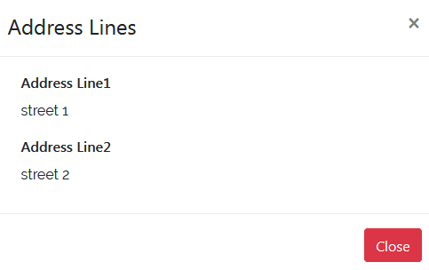

**Figure 7.4.6.7**

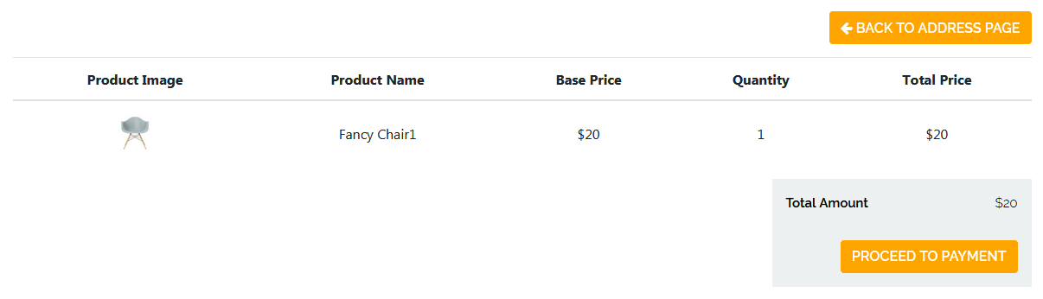

**Figure 7.4.6.8**

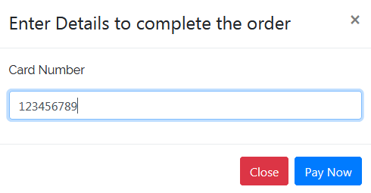

**Figure 7.4.6.9**

|  |  |  |  |  |
| --- | --- | --- | --- | --- |
| **Requirement Type**: | | | Functional Requirement | |
| **Description:** | | The buyer is able to select the product of type sale and can place the order by following the below steps :   1. User will click the “Add to Cart” option from the sales product list (Figure 7.4.6.1) 2. User can view and click the “Add to Cart” option form the product view page (Figure 7.4.6.2) 3. Once the product is added to the cart ,the cart count is updated (Figure 7.4.6.3) 4. User will click the cart icon from the header to continue his order. (Figure 7.4.6.3) 5. The shopping cart is opened with the following details of the product.  * Product Image * Product Name * Category * Base Price * Quantity ( it can be varied up to the maximum quantity of the product) * Price of an order * Total Price of all the orders * Coupon code option (if user has any coupon code, then he can enter this code by clicking on the “Have Coupon Code?” (figure 7.4.6.5) * “Confirm Address” button  1. When user clicks the Confirm Address button , the address confirmation page is shown ,where user confirm his address  * Address details * “Back to Cart page” button which will take the user back to cart page * Vie Button ,by which user can view his address lines (figure 7.4.6.7) * Continue Button   See figure 7.4.6.6 for more details   1. When user click the “continue” button , the confirm order page will be appeared. Following information will be displayed on this page (figure 7.4.6.8).  * Product image * Product Name * Base Price * Quantity * Total Price * Total Amount * “Back to Address Page” button ,this will take the user back to the address page * “Proceed to Payment” button  1. When user clicks the Proceed to payment button , then payment page is appeared on the screen(also attach the updated SS) 2. Once the payment procedure is successful, thank you page will be shown to the user. | | |
| **Rationale:** | | This will help the user to place order and complete the payment procedure of the selected order. | | |
| **Fit Criteria:** | | Authorized buyers | | |
| **Source:** | |  | | |
| **Supporting Material (if any):** | | | | Client Meetings |
| **History:** |  | | | |

**7.4.7 Auction Product Bidding Process**



**Figure 7.4.7.1**

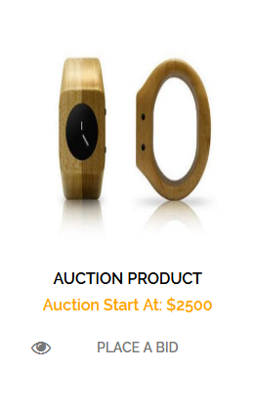

**Figure 7.4.7.2**

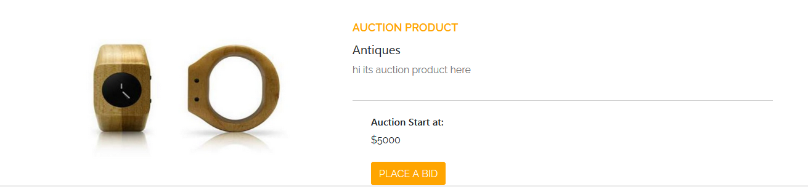

**Figure 7.4.7.3**

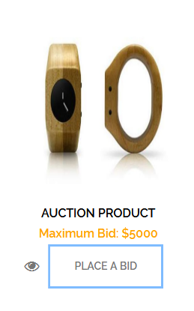

**Figure 7.4.7.4**

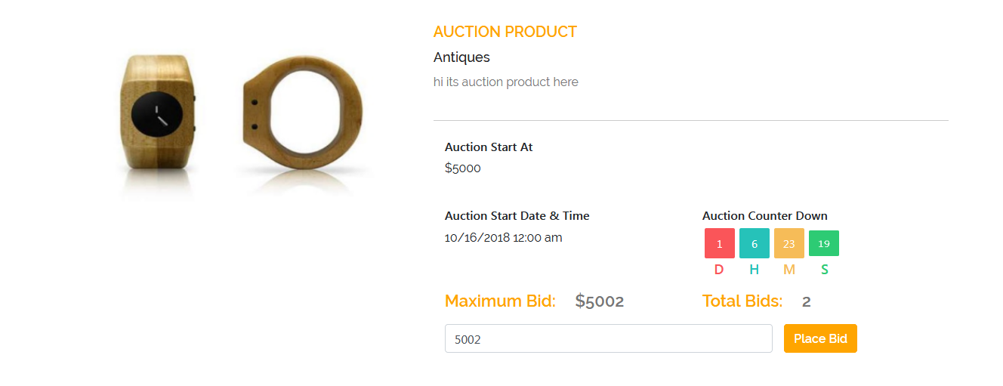

**Figure 7.4.7.5**

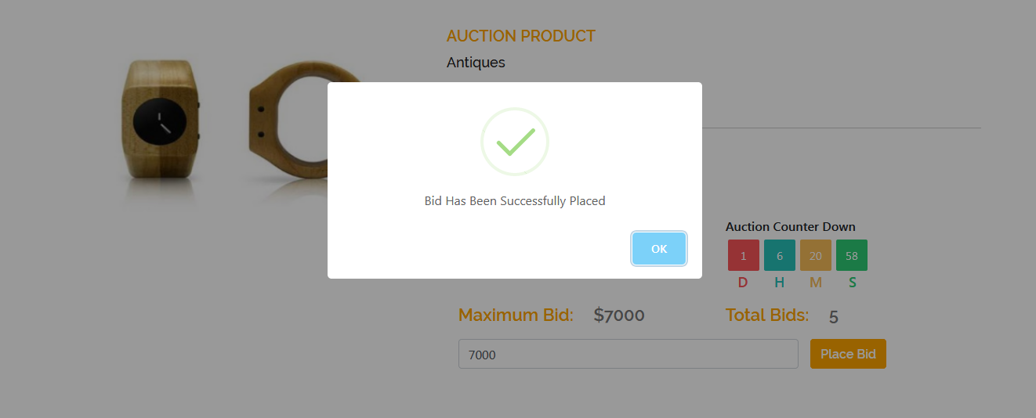

**Figure 7.4.7.6**

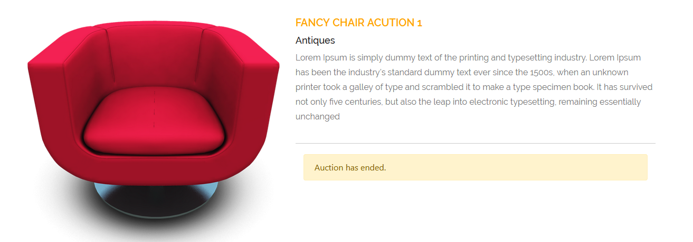

**Figure 7.4.7.7**

|  |  |  |  |  |
| --- | --- | --- | --- | --- |
| **Requirement Type**: | | | Functional Requirement | |
| **Description:** | | The buyer will be able to get the auction products.   1. Buyer will search for the auction product by clicking the “Auctions ” option from the header (figure 7.4.7.1) 2. Each auction product in the list will contain the following information  * Product Name * Price which depict that at this amount auction will be started * View icon .By clicking this buyer will be able to view the product. User will be able to place the bid from this section as well (figure 7.4.7.3) * “Place A Bid” option ,by clicking this user will be able to place bid for that product * If some other buyer has placed a bit for that product already ,then in the auction product list ,the maximum bid of that product will be displayed (Figure 7.4.7.4 ) * User has to place the bid greater than the maximum bid  1. When buyer clicks the “place a Bid” option, the product bid page will be appeared on screen. It will contain the following functionality (figure 7.4.7.5)  * Product Name * Product Image (images) * Product category * Product description * Price at which auction will be started * Auction Stat Date and Time * “Auction Count Down”. This is the counter that will count the remaining time of the auction product. It will show the Days ,Hours ,Minutes and Seconds of the auction remaining time * Input field which will take bid input of the user for the auction product * “Place Bid” button , which will submit the bid amount of the buyer  1. Once buyer bid has been accepted, he will be shown a success message (figure 7.4.7.6). 2. Once the auction expiry date is passed, then buyer will not be able to place bid for that product. 3. When buyer view expired auction product from the list , he will be shown the message “ Auction has ended”   See figure 7.4.7.7 for more information. | | |
| **Rationale:** | | This will help the user to place bid for the auction product. | | |
| **Fit Criteria:** | | Authorized buyers | | |
| **Source:** | |  | | |
| **Supporting Material (if any):** | | | | Client Meetings |
| **History:** |  | | | |

**EASE OF USE**

Not Applicable

Ease of learning

It should be very user friendly with proper flow and proper error messages.

Security Requirements

The website must have an SSL certificate installed and the login page will be used only under the SSL. If the user enters the login page under HTTP, they will be redirected to the HTTPS to login.

## Response Time

The application will also need to have a timeout script to redirect the window to the login screen when the application times out.

## Startup Time

Not Applicable

## Shutdown Time

Not Applicable

## Number of Terminals

Not Applicable

## Number of Simultaneous Users

Not Applicable

## Expected Technological Requirements

Preferred Technology will be C#.net. MSQL server 2005 and use of AJAX is very critical to where even post backs can be eliminated.

## Application Partner

Not Applicable

## Legal Requirements

Not Applicable

## Open Issues

* Requirements change with time due to business reasons
* Development cost exceeds
* A site is not fully done when launches
* Resource unavailable during the development phase
* Website stops responding when accessed by many users at a time

## Off the shelf solutions

Not Applicable

## Cutover

Not Applicable

## Risks

* The website can be easily hacked
* Website can easily be break
* Login credentials of user can be accessed by hackers
* Credit card information of user can be easily hacked

## User Documentation and Training

Users will be provided with a comprehensive SRS document (this document).

**SRS Signoff**